Athena:

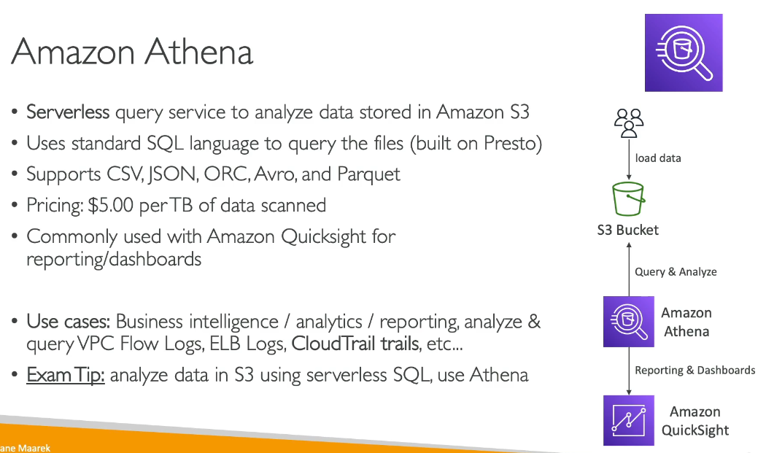

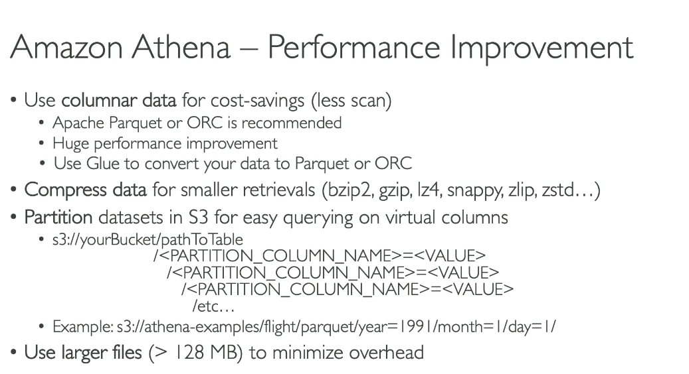

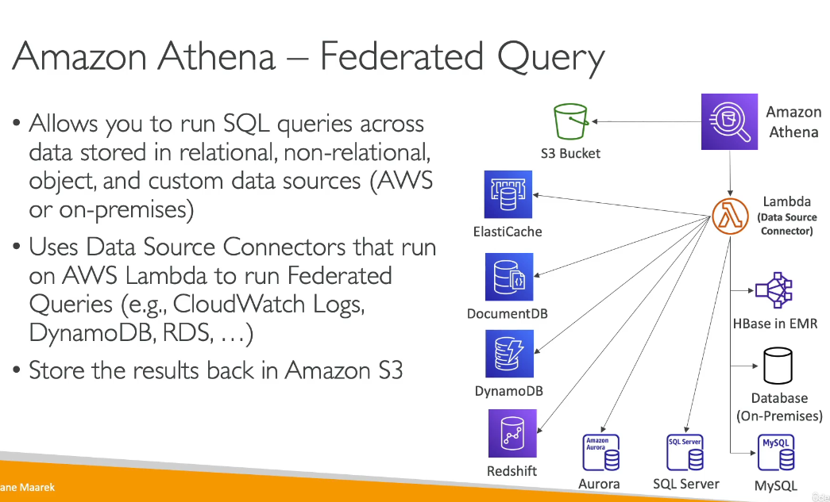

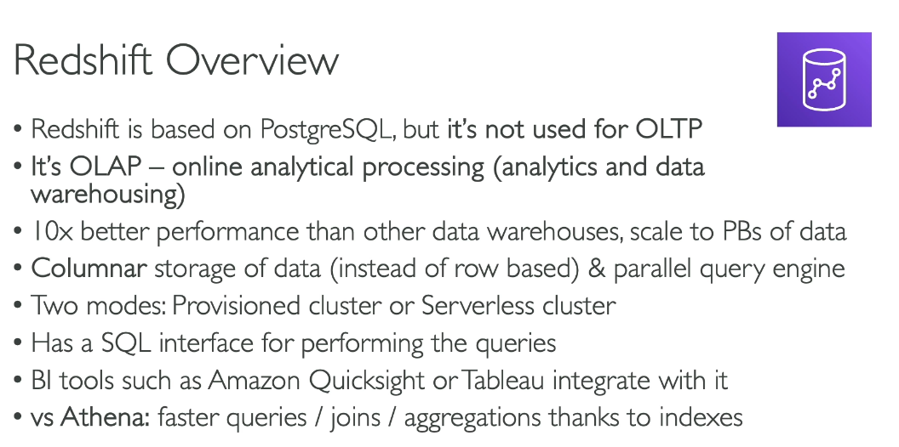

**Difference between Database & Data Warehouse**

Database:

* Designed for Online Transaction Processing (OLTP)
* Handles day-to-day operational transactions (inserts, updates, deletes)
* Optimized for fast query response times and concurrent users
* Stores current, detailed data
* Examples: Amazon RDS, Amazon Aurora, Amazon DynamoDB

Data Warehouse:

* Designed for Online Analytical Processing (OLAP)
* Handles complex queries and analytics on large datasets
* Optimized for read-heavy operations and aggregations
* Stores historical data from multiple sources for analysis
* Supports business intelligence and reporting
* Example: Amazon Redshift

Key Differences:

* Purpose: Databases support daily operations; data warehouses support analytics and decision-making
* Data Structure: Databases use normalized structures; data warehouses use denormalized structures optimized for queries
* Performance: Databases prioritize transaction speed; data warehouses prioritize query performance on massive datasets
* Scale: Data warehouses handle much larger volumes of data across multiple databases Data warehouses extend relational database capabilities on a massive scale, enabling SQL querying for storing and analyzing data across numerous databases.

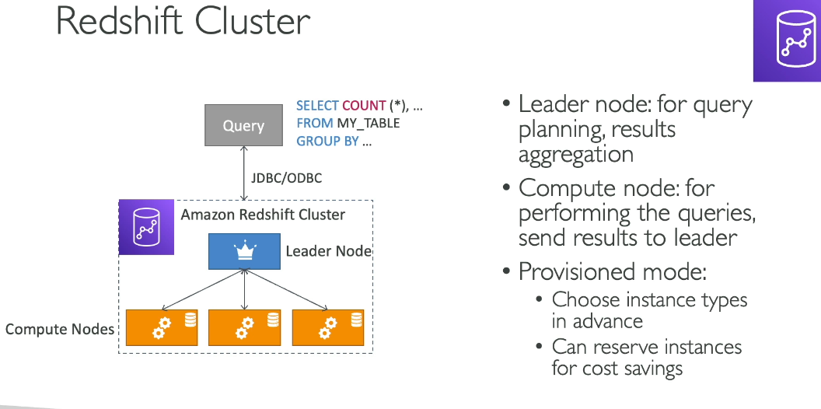

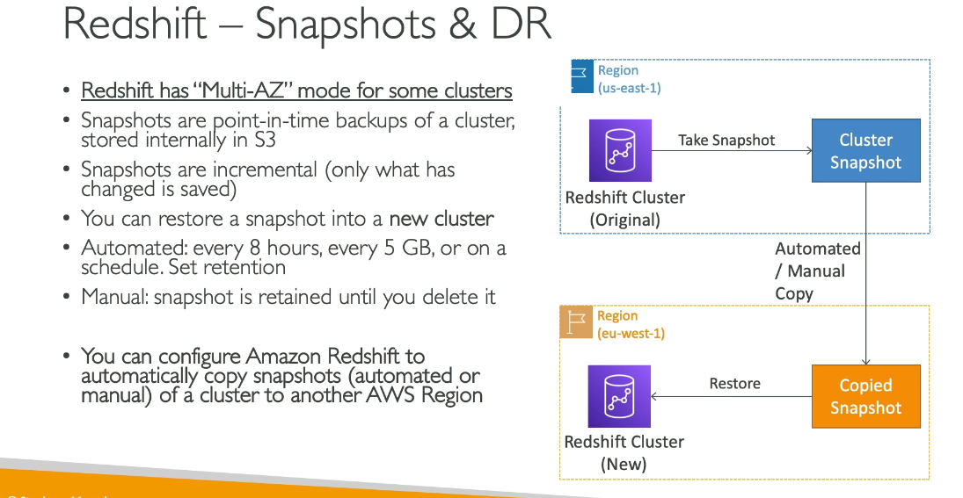

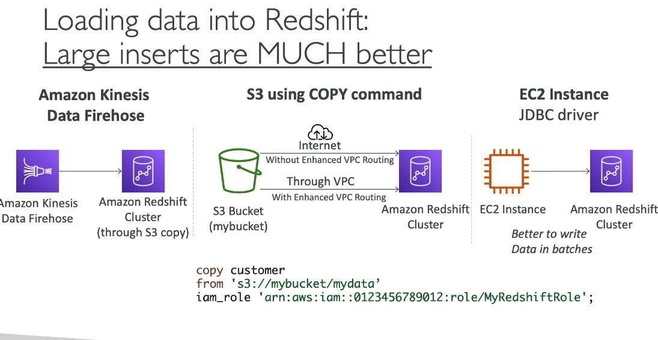

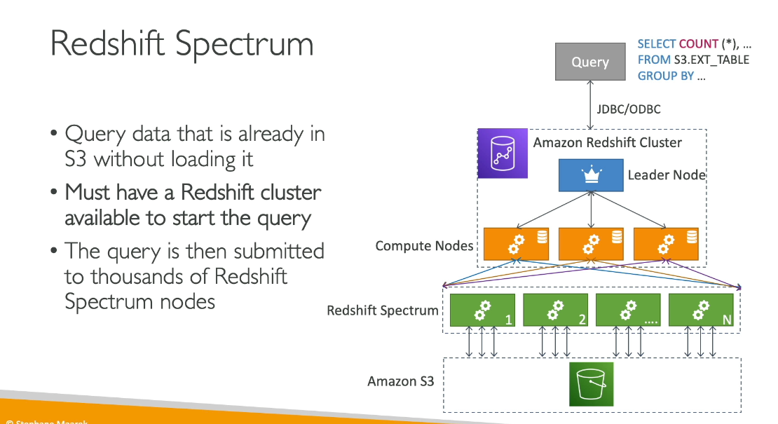

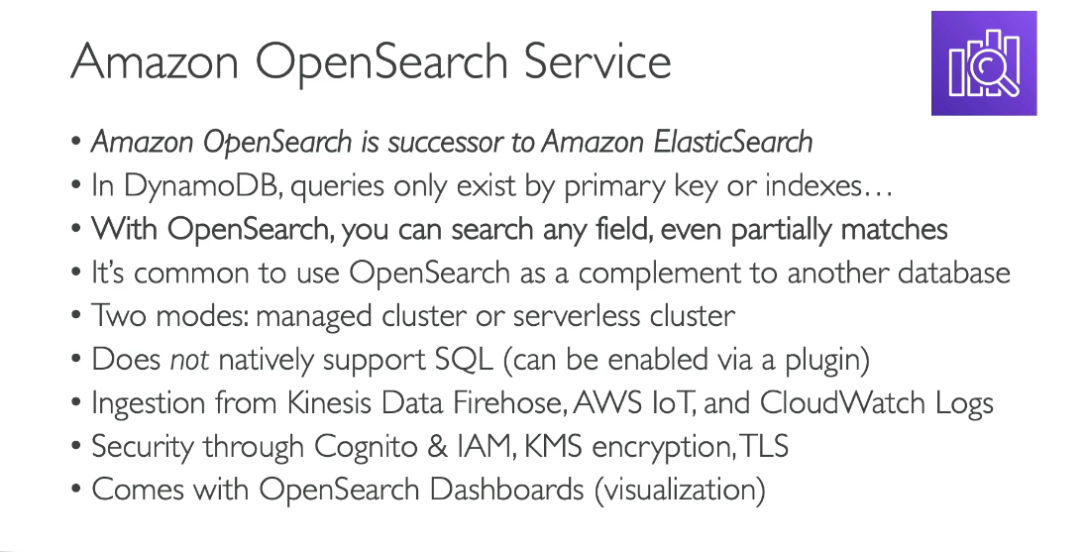

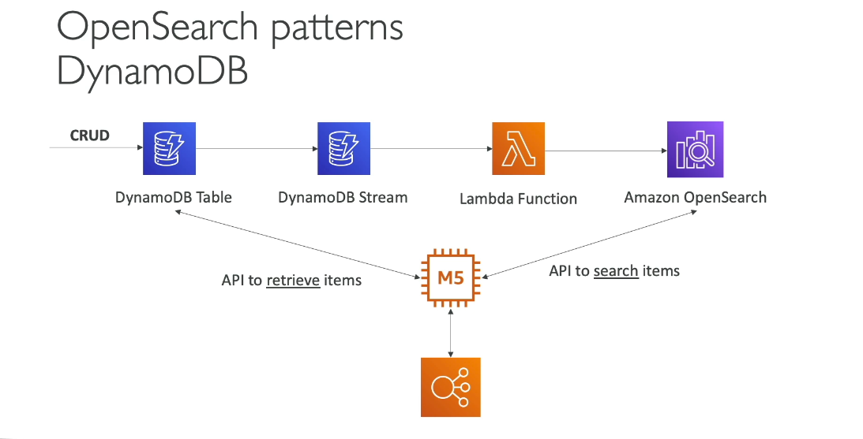

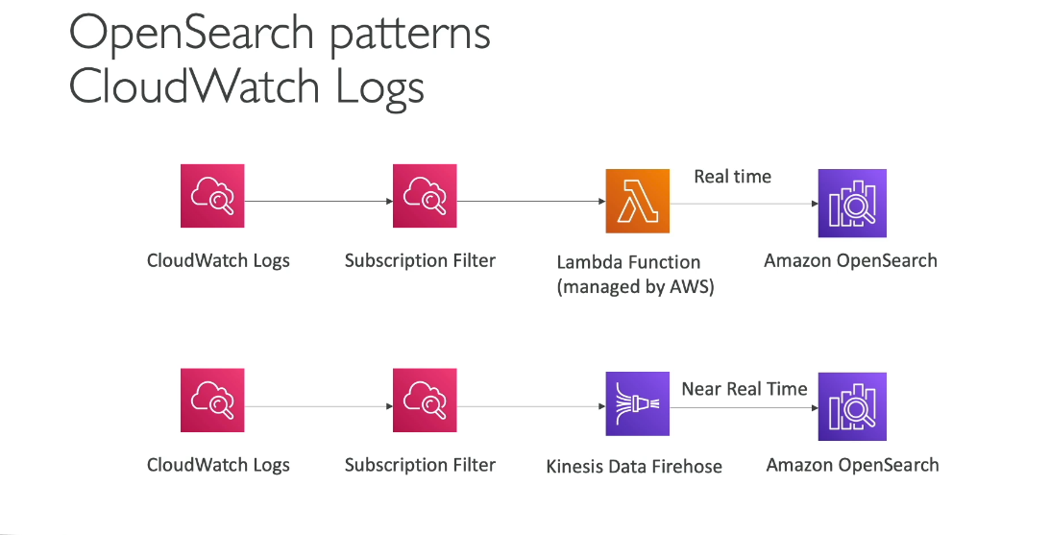

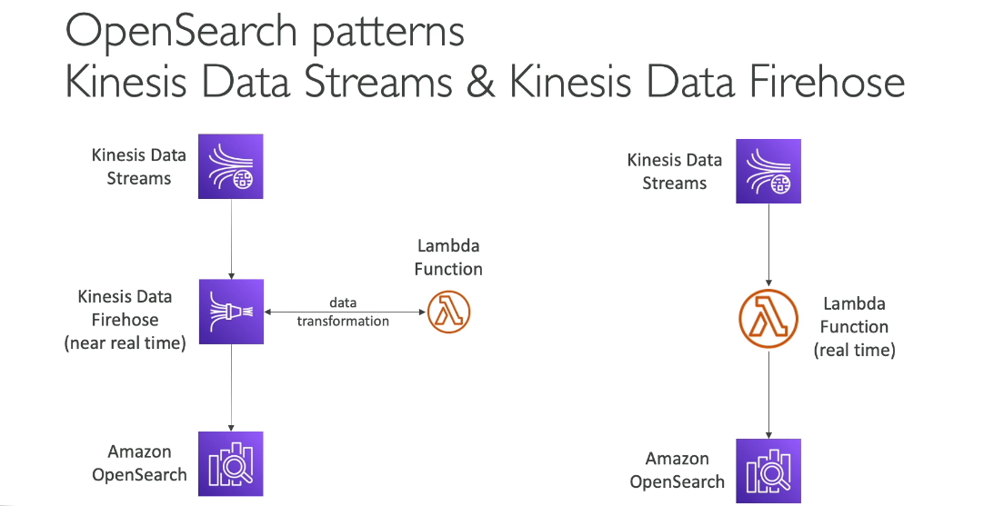

Difference between RedShift and Opensearch:

**Amazon OpenSearch Service:**

* Purpose: Search and analytics engine for log analytics, real-time application monitoring, and website search
* Data Type: Optimized for unstructured and semi-structured data (logs, documents, JSON)
* Use Cases: Full-text search, log analytics, real-time monitoring, application search
* Query Language: OpenSearch Query DSL (Domain Specific Language)
* Storage: Stores data in indices with document-oriented structure
* Performance: Optimized for fast search and retrieval operations

**Amazon Redshift:**

* Purpose: Data warehouse for complex analytical queries on large datasets
* Data Type: Optimized for structured data (tables with rows and columns)
* Use Cases: Business intelligence, reporting, complex analytics, historical data analysis
* Query Language: Standard SQL
* Storage: Stores data in columnar format within clusters
* Performance: Optimized for complex queries with joins, aggregations, and subqueries

Key Difference: OpenSearch excels at search and real-time analytics on unstructured data, while Redshift is designed for complex analytical queries on structured data warehouses. OpenSearch is ideal for searching through logs and documents, whereas Redshift is best for business intelligence and data analytics on large structured datasets.

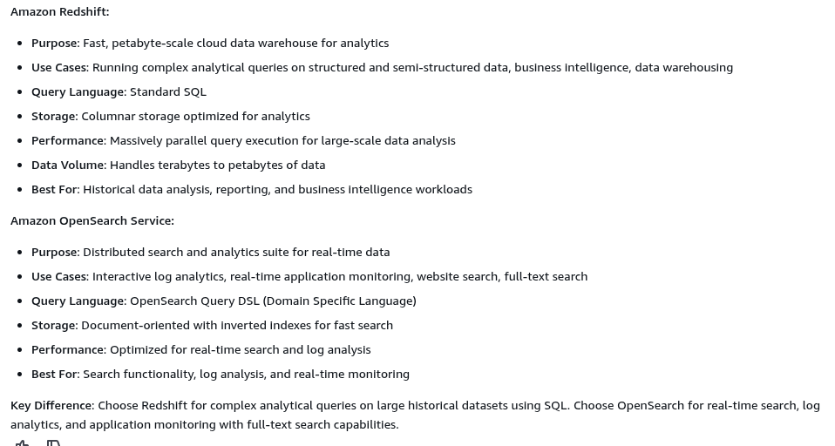

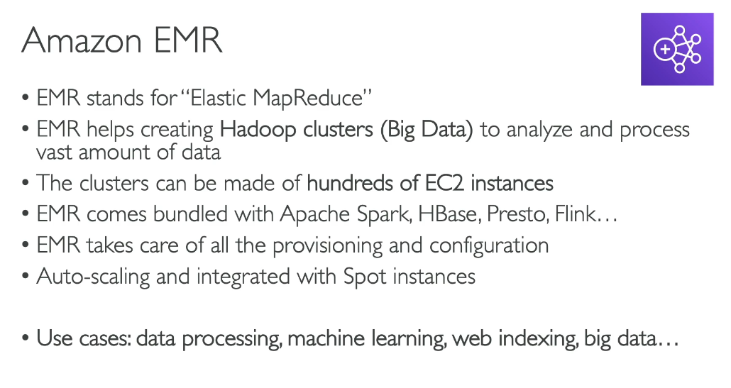

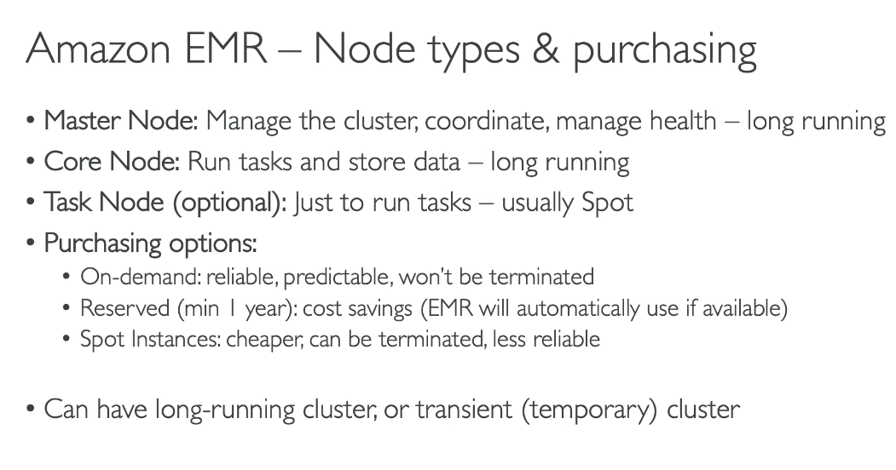

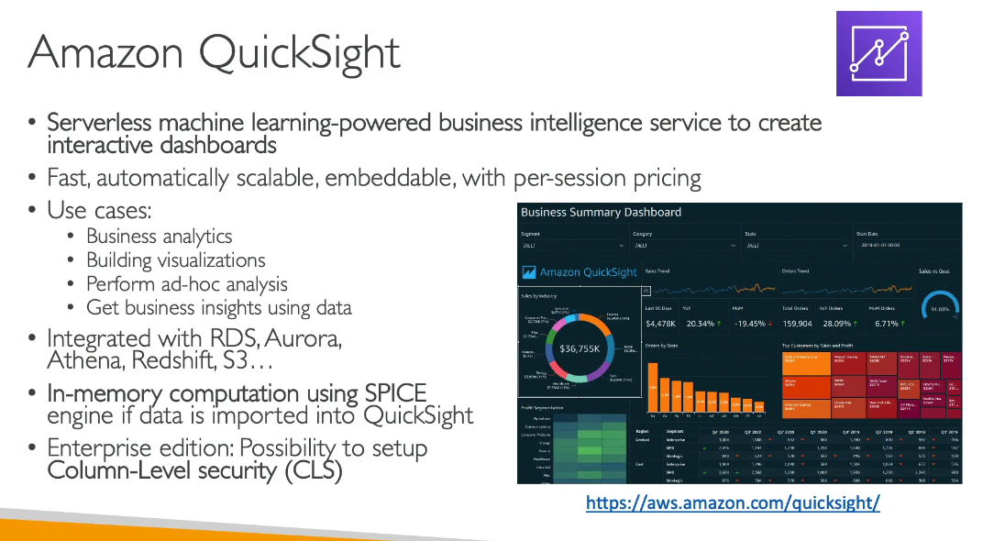

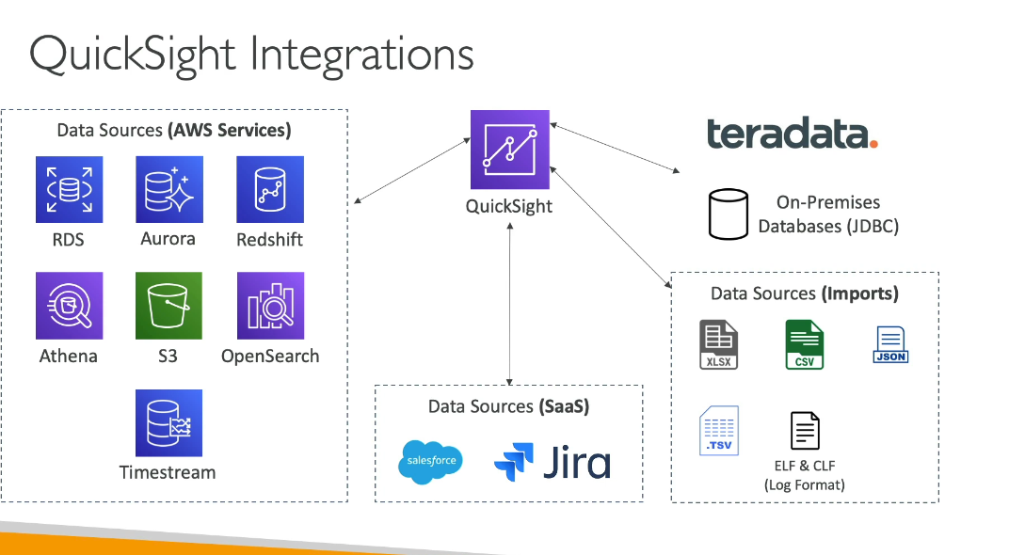

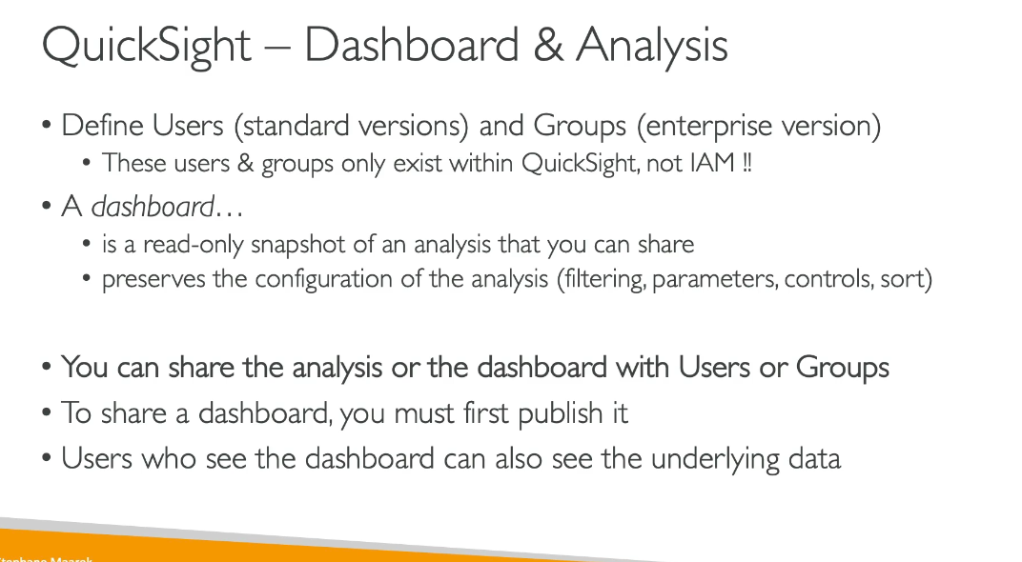

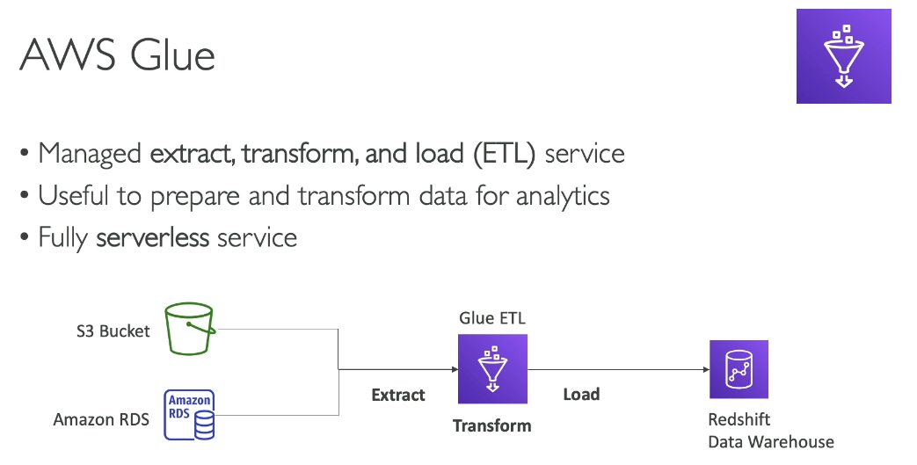

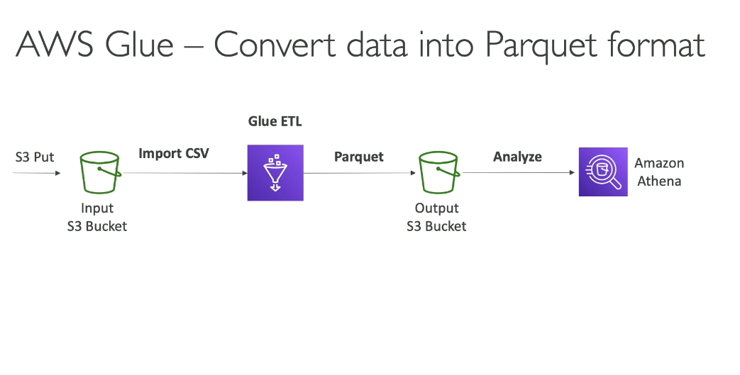

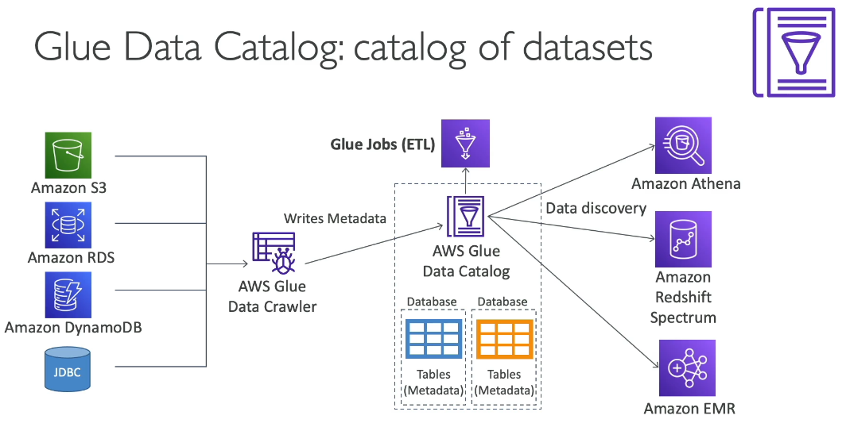

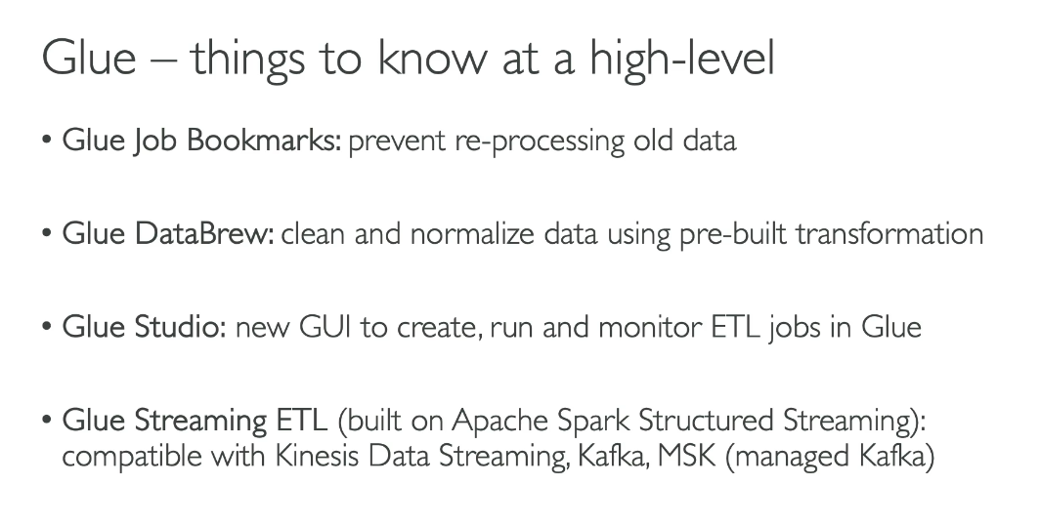

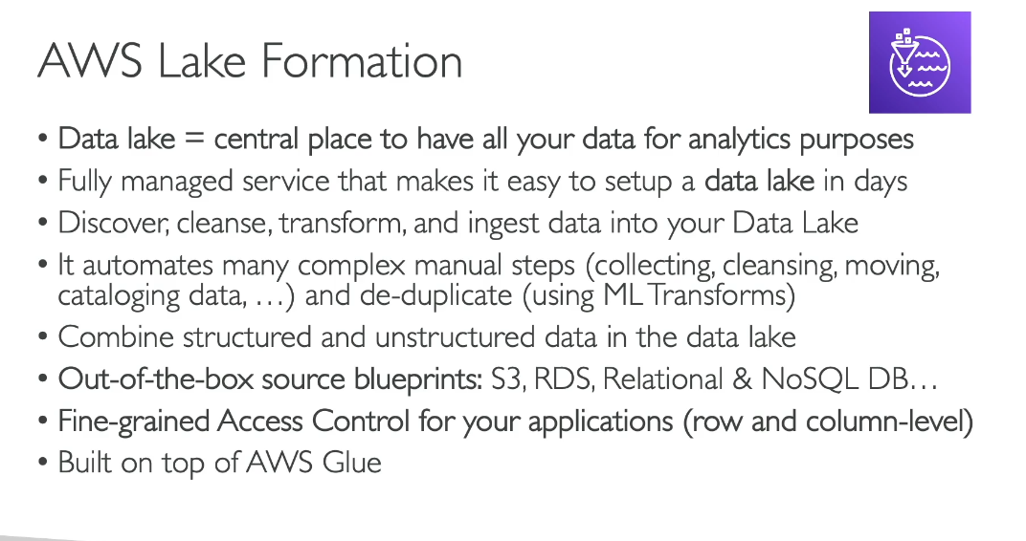

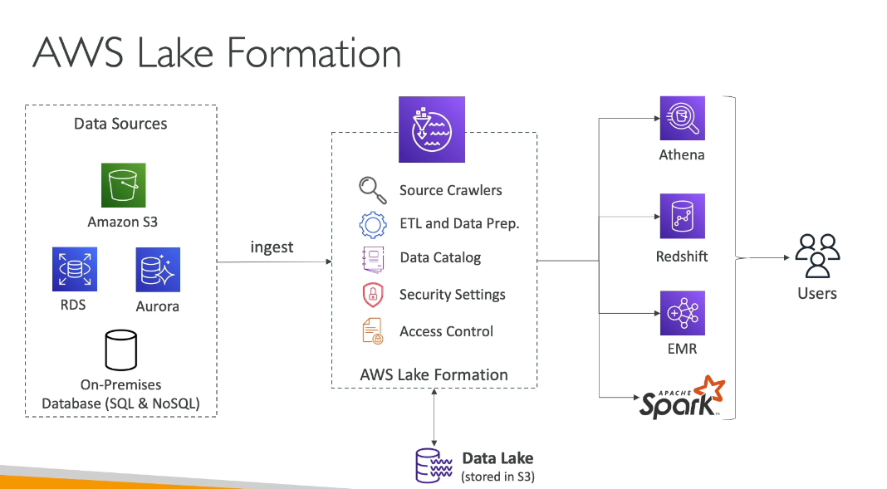

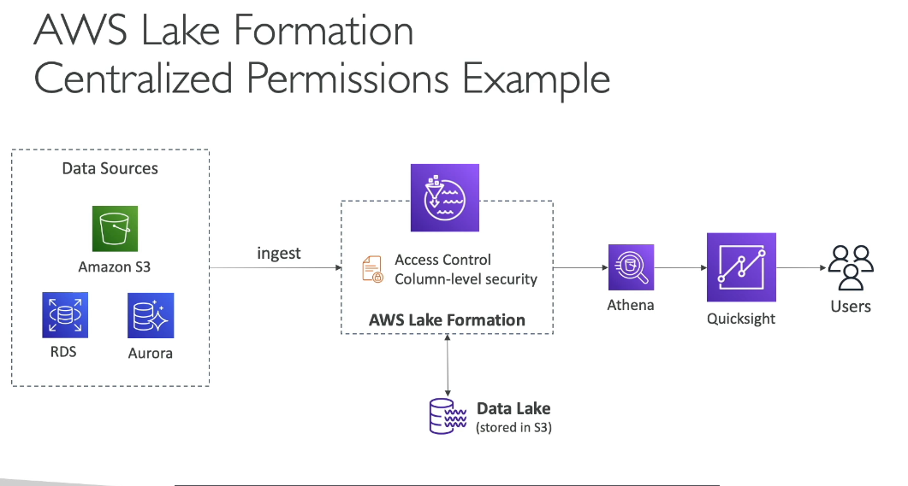

**AWS Glue:**

* ETL Service: Serverless data integration service for discovering, preparing, and transforming data
* Data Catalog: Provides a centralized metadata repository for data assets
* Core Functions: Crawlers to discover data, ETL jobs to transform data, and catalog management
* Use Case: Building and running ETL pipelines to move and transform data

**AWS Lake Formation:**

* Data Lake Management: Makes it easier to set up, secure, and manage data lakes
* Built on AWS Glue: Uses AWS Glue Data Catalog and shares the same catalog
* Security & Governance: Centralized data security, fine-grained access control (row and column level), and data sharing capabilities
* Core Functions: Register data locations, define access policies, audit data access, and share data across organizations

**Key Differences:**

* Scope: Glue focuses on ETL and data integration; Lake Formation focuses on data lake governance and security
* Access Control: Lake Formation adds fine-grained permissions on top of IAM, while Glue relies primarily on IAM
* Relationship: Lake Formation is built on Glue and extends its capabilities with security and governance features In Practice: Use Glue for ETL workflows and data cataloging. Add Lake Formation when you need centralized security, fine-grained access control, and data sharing across your data lake.

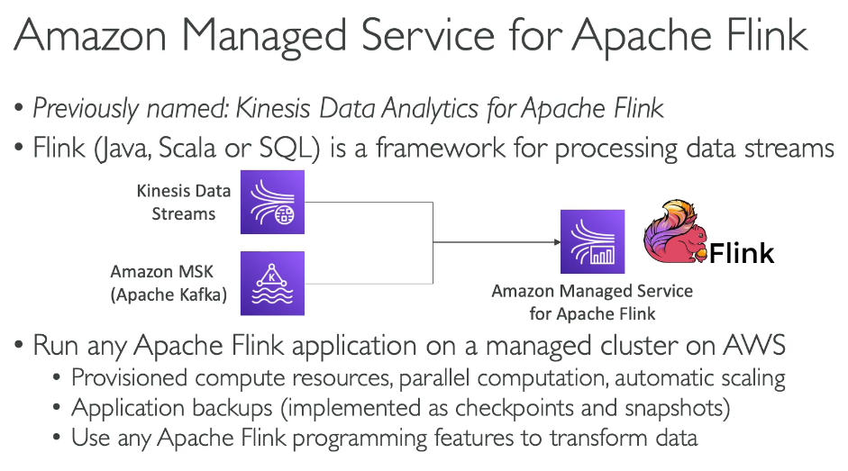**AWS Managed Flink cannot read from Kinesis Data Firehouse**

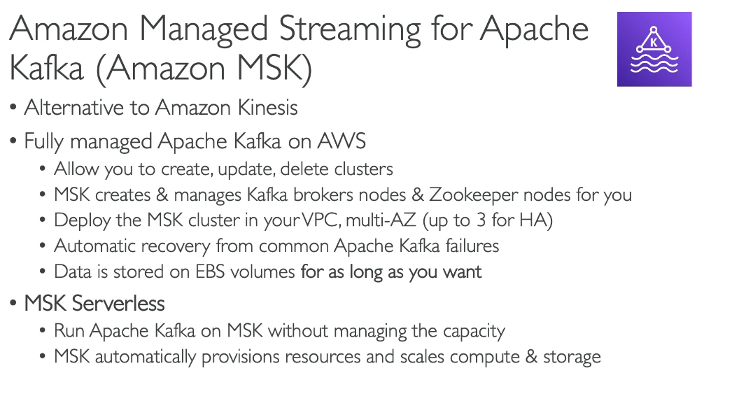

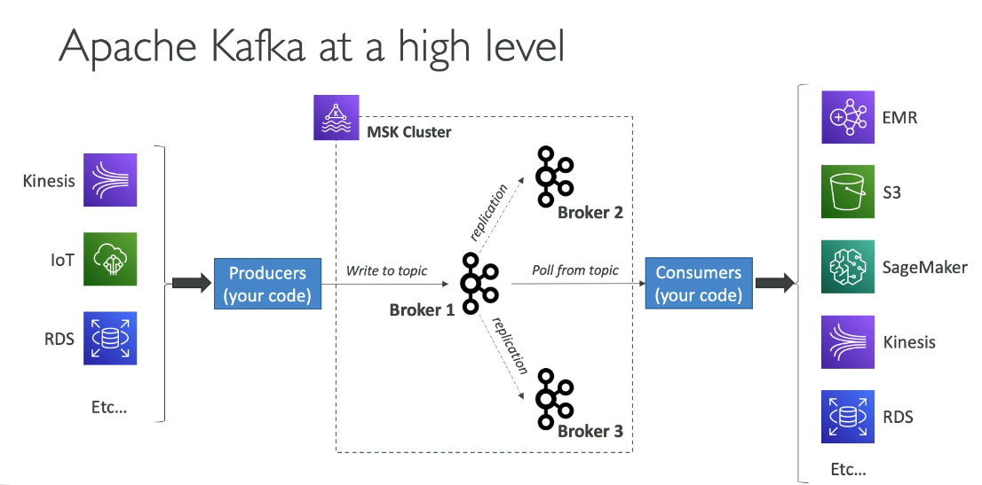

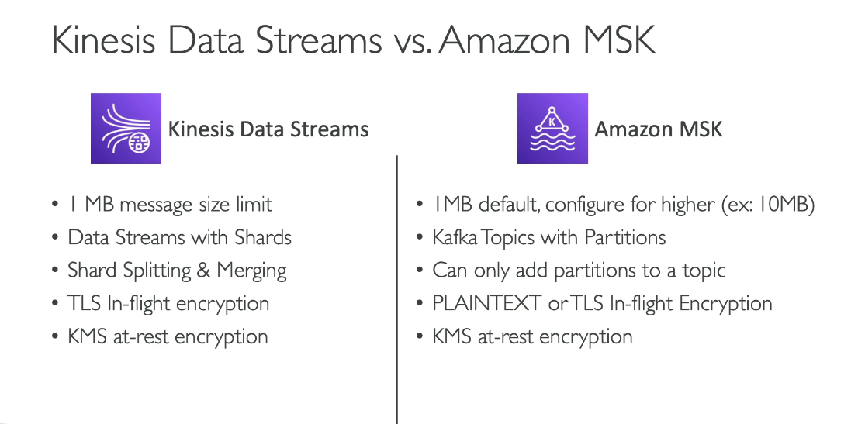

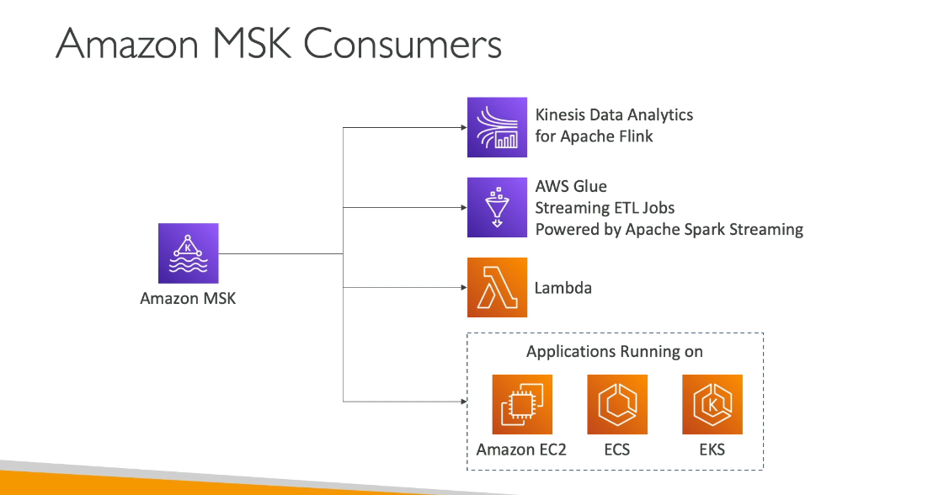

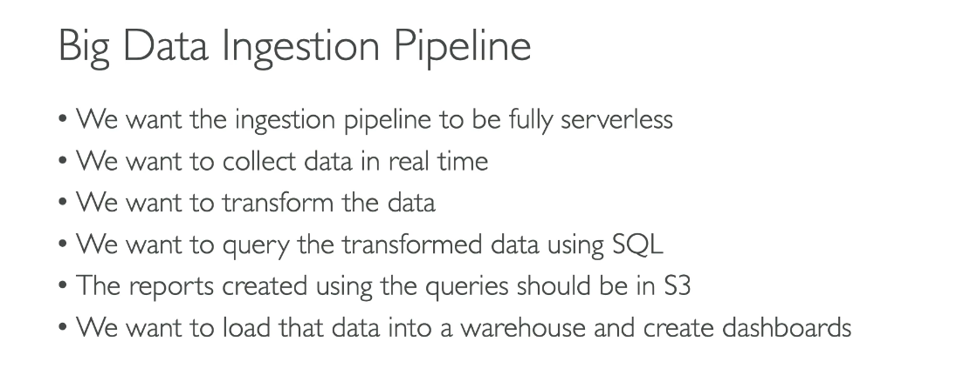

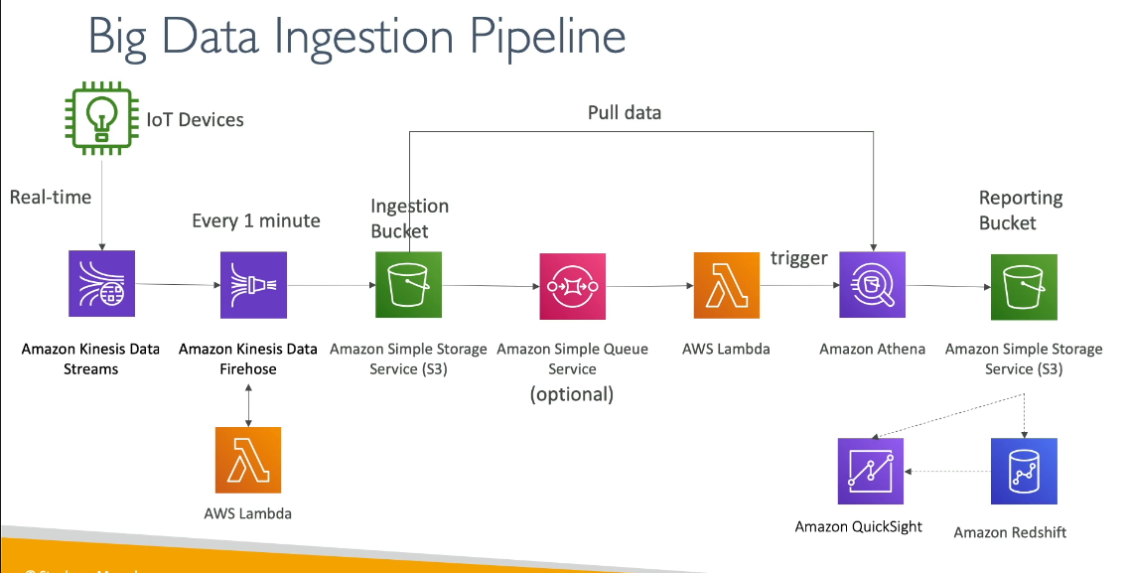

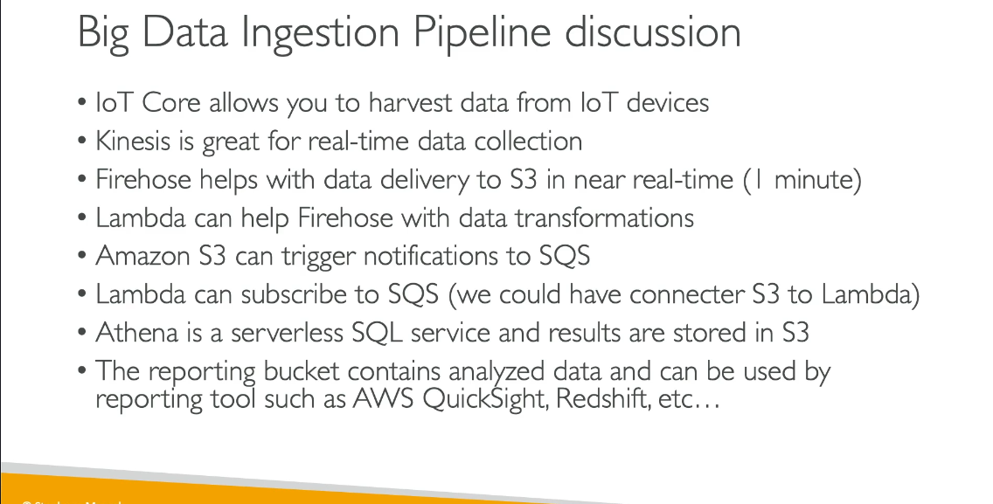

**AWS Managed Services:**

All the services you listed are AWS managed services, meaning AWS handles infrastructure, patching, and maintenance:

* Amazon Athena
* Amazon Redshift
* Amazon OpenSearch Service
* AWS Glue
* AWS Lake Formation
* Amazon EMR
* Amazon QuickSight
* Amazon Managed Service for Apache Flink
* Amazon MSK (Managed Streaming for Apache Kafka)

**Serverless Services:**

Services where you don't provision or manage servers:

* Amazon Athena: Fully serverless query service
* AWS Glue: Serverless data integration (crawlers, ETL jobs)
* AWS Lake Formation: Serverless data lake management
* Amazon QuickSight: Serverless BI service
* Amazon Managed Service for Apache Flink: Serverless stream processing
* Amazon Redshift Serverless: Serverless option available (note: Redshift also offers provisioned clusters)

Provisioned/Managed (Not Serverless):

Services where you provision and manage cluster capacity:

* Amazon EMR: Provision EC2 instances for clusters
* Amazon MSK: Provision broker nodes and storage
* Amazon Redshift (Provisioned): Provision cluster nodes
* Amazon OpenSearch Service: Provision domain instances

Both Options Available:

* Amazon Redshift: Offers both provisioned clusters and Redshift Serverless

Quiz:

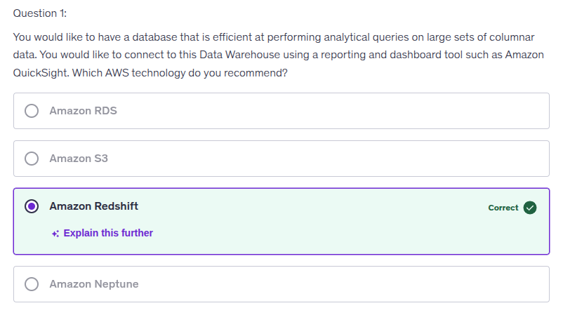

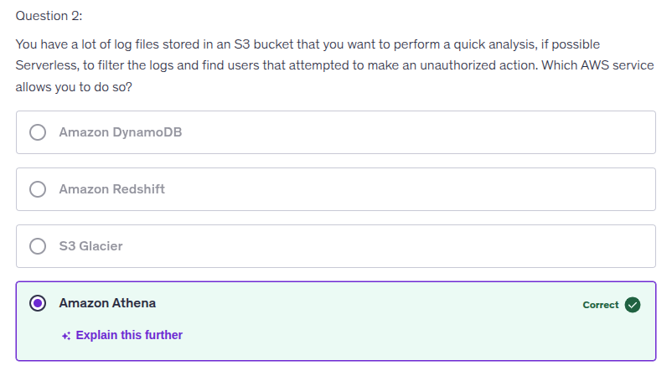

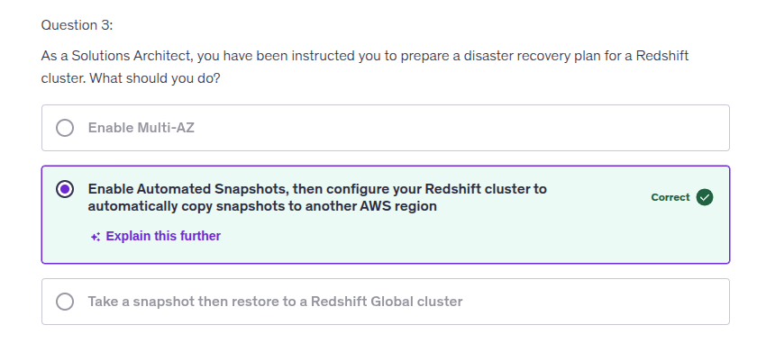Redshift’s so-called “Multi-AZ” only provides high availability within a single region for RA3 clusters by spreading metadata and managed storage access across multiple AZs, but it does **not** create a standby cluster or protect you from regional outages. It is **not** a disaster recovery solution. True DR for Redshift requires **automated snapshots and cross-region snapshot copies**, so that if the primary region fails you can restore the cluster in another region.

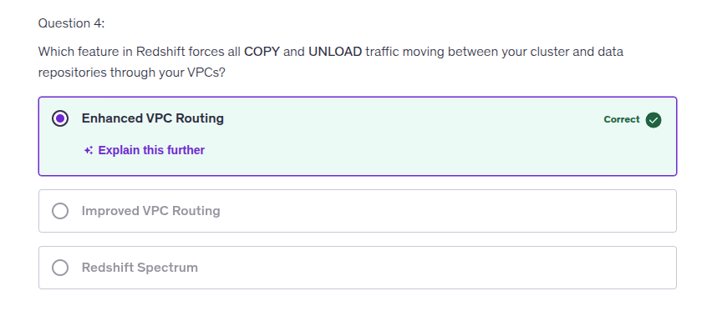

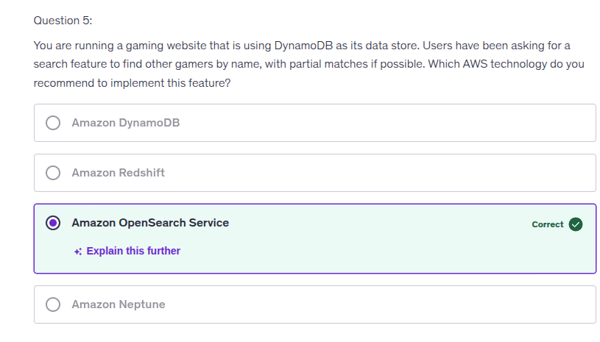For realtime and partial search = Opensearch

